MK2 FILMS PRESENTS

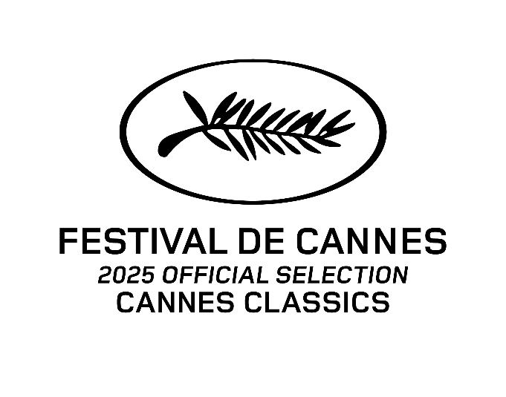

MERLUSSE

A FILM BY

MARCEL PAGNOL

1935 – FRANCE – DRAMA – B&W 72’ – NEW 4K

SYNOPSIS

In Marseille, the boarding school at Lycée Thiers empties as Christmas approaches. Just a handful of pupils from diverse backgrounds remain to spend the holidays there, under the austere watch of Blanchard — a one-eyed, much-feared school monitor known to all the boys as “Merlusse.”

**MERLUSSE was restored in 4K in 2025 by CMF-MPC and the Cinémathèque française. With the support of the CNC, the Région Sud, and the Marcel Pagnol Endowment Fund. Restoration carried out by the Transperfect Media laboratory. Colour grading by Guillaume Schiffman.**

*“No one who loves Pagnol can miss his wonderful* Merlusse*, a lesser-known, autobiographical film about his youth in Marseilles -- a film that, along with Renoir’s Toni, anticipates neo-realism with its use of locations and mix of professional and non-professional actors.  When I first saw it years ago,* Merlusse *captivated me to such an extent that it inspired my own film* The Holdovers*.”*

- Alexander Payne

130TH ANNIVERSARY OF MARCEL PAGNOL

In 2025, France celebrates the 130th anniversary of the birth of Marcel Pagnol. A filmmaker, writer, and even a member of the Académie Française, Pagnol remains a major figure in French culture, known for his deep attachment to Provence and his universal portrayals of family and childhood. To mark this occasion, numerous events are being organised: theatrical productions, exhibitions, screenings of restored films, and the release of the animated film *Marcel and Monsieur Pagnol*, directed by Sylvain Chomet. The Cannes Film Festival pays tribute to Marcel Pagnol 70 years after his presidency and the awarding of the first Palme d’Or.

ABOUT THE FILM

**MERLUSSE**, the first original screenplay written by Marcel Pagnol for the cinema, was filmed during the Christmas holidays at the Lycée Thiers in Marseille, where the filmmaker had studied. Pagnol chose the child actors from the actual students at the school.

The film perfectly illustrates the debate over 'filmed theatre':

*"I take into account all the possibilities that cinematographic technology offers me, but that doesn’t prevent me from building the action as solidly as I would for the stage, and writing dialogue as if it were meant to be spoken on stage.”*

Marcel Pagnol

MARCEL PAGNOL

***"That is the lesson of Pagnol: when you left one of his films, you felt happy.   
Sometimes, you even felt a little better."*** Jean-Charles Tacchella

**Born in Aubagne on 28 February 1895**, Marcel Pagnol received a classical and republican education with a touch of anti-clericalism.

In 1916, he entered the teaching profession. He was appointed as a teaching assistant in Digne, Pamier, Tarascon, and then in Paris in 1922. During his free time, he wrote plays in verse and ancient dramas. In 1926, his play 'Jazz' premiered in Monte Carlo to great acclaim, launching his career. This was followed by **three of the greatest successes in French theatre:** “Topaze” in 1928, “Marius” in 1929, and “Fanny” in 1931. That same year, his meeting with Bob Kane, the director of **Paramount France**, provided the opportunity to bring 'Marius' to the screen. The **success was phenomenal**, coinciding with the rise of talking pictures. Pagnol then decided to establish his own production company, abandoning theatre for cinema.

He turned a new page, founding his own studios in Marseille and a magazine, “**Les Cahiers du Film**”, to promote his vision of cinematic art: the dialogue must take precedence over the image. Through this approach, he established the supremacy of the writer over the director. This might seem commonplace today, but in the 1930s, film theory was still heavily influenced by silent cinema, where directors held dominant creative control.

He dedicated himself to this new medium until 1954, producing and directing over twenty films, including *Fanny*, *Topaze'* *Angèle*, *César*, *The Well-Digger's Daughter*, *The Baker's Wife*, *Regain*, *Manon des Sources*, *Naïs*, and others.

In 1946, he became the first filmmaker elected to the **Académie Française**. He then turned increasingly to prose writing, starting with his cinematic memoir *Cinématurgie de Paris*, followed by the sharp critique 'Critique des Critiques' and an essay on the nature of laughter, “Notes on Laughter”.

**In 1955, Pagnol ended his filmmaking.** After a brief return to theatre with “Judas” and “Fabien”, he embarked on his “Souvenirs d’enfance*”* series: “The Glory of My Father” and “The Château of My Mother”.

Looking back at his life, it seems that the medium mattered little to Marcel Pagnol. Only creative freedom was of real importance to him. Thus, he left the constraints of theatre for the creative liberty of the camera.

**Playwright, novelist, filmmaker**, essayist, polemicist, historian, as well as studio director, distribution agency owner, producer, and press director – he was above all a curious and enlightened man, much like a scientist of the Enlightenment.

Marcel Pagnol passed away in Paris on 18 April 1974.

# **MK2 FILMS: THE MARCEL PAGNOL COLLECTION**

1956 The Ladies’ Terror directed by Jean Boyer

1954 Letters From my Windmill - HD

1953 Carnival directed by Henri Verneuil

1952 MANON OF THE SPRINGS - 4K

1952 Ugolin - 4K

1951 Topaze (3) directed by Louis Gasnier - 2K

1950 The Prize directed by Jean Boyer - HD

1947 The Pretty Miller Girl - HD

1945 Nais directed by Raymond Leboursier - 2K

1941 THE WELL-DIGGER’S DAUGHTER - 4K

1938 The Baker’s Wife - 4K

1937 Heartbeat - 2K

1937 Harvest - 4K

1936 Topaze (2)

1935 Cesar - 4K

1935 Merlusse – 4K

1935 Cigalon – 4K

1934 Angèle - 4K

1933 Mr. Poirier’s Son-in-law

1933 Jofroi - 4K

1932 Fanny - 4K

1932 Topaze (1)

1931 Marius - 4K

# **CAST & CREW**

**CAST**

Merlusse Henri Poupon

The Headmaster André Pollack

The Dean Thommeray

The Senior Supervisor André Robert

The Porter Rellys

Nathalie Annie Toinon

Galubert Jean Castan (credited as Castagne)

Catusse Fernand Bruno (credited as F. Bruno)

Godard Robert Chaux

Villepontoux Le petit Jacques

“Macaque” Le-Van-Kim

Pic John Dubrasi

**CREW**

Directed by Marcel Pagnol

Assistants Pierre Arnaudy, Clément Maure, Charles Pons

Written by Marcel Pagnol

Dialogue Marcel Pagnol

Photography Albert Assouad, Roger Ledru

Music Vincent Scotto

Editing Suzanne de Troeye

Production Les Films Marcel Pagnol

New Restoration CMF-MPC and Cinémathèque Française

With the support of CNC, Région Sud

And Fonds de Dotation Marcel Pagnol

International Sales mk2 Films

# **INTERNATIONAL SALES**

**INTERNATIONAL SALES: MK2 FILMS**

|  |  |  |
| --- | --- | --- |
| **FRÉDÉRIQUE ROUAULT**  Head of Collections  +33 (0)7 72 26 33 38  [frederique.rouault@mk2.com](mailto:frederique.rouault@mk2.com) | **JACQUES-ANTOINE JAGOU**  International Sales - Library  +33 (0)6 67 66 26 02  [jacques.jagou@mk2.com](mailto:jacques.jagou@mk2.com) | **QUENTIN BOHANNA**  International Sales  +33 (0)6 31 86 77 69  [quentin.bohanna@mk2.com](mailto:quentin.bohanna@mk2.com) |
| **ROSALIE VARDA**  Senior Advisor  +33 (0)6 07 72 14 00  [rosalie.varda@mk2.com](mailto:rosalie.varda@mk2.com) | **FIONNUALA JAMISON**  Managing Director  +33 (0)7 60 83 94 98  [fionnuala.jamison@mk2.com](mailto:fionnuala.jamison@mk2.com) | **BENOIT CLARO**  Head of Marketing  +33 (0)6 70 53 33 23  [benoit.claro@mk2.com](mailto:benoit.claro@mk2.com) |
|  |  |  |
|  |  |  |

**HEAD OFFICE**

mk2 Films

55 rue Traversière

75012 Paris France

+ 33 (0)1 44 67 30 30

[intlsales@mk2.com](mailto:intlsales@mk2.com)

[[[DOWNLOAD NEW IMAGES]](https://mk2films.com/en/film/merlusse/)](https://mk2films.com/en/film/four-nights-of-a-dreamer/)