
PRESENTS

  GOLDEN LION  MOSTRA DE VENISE 1985 |   BEST ACTRESS  CÉSAR 1986

VAGABOND

A FILM BY
AGNÈS VARDA

1985 – FRANCE – 105’ – 2K

DISTRIBUTION : mk2 Films
distrib@mk2.com
PRESS CONTACT : Monica Donati
monica.donati@mk2.com
PRESS KIT : [ACCÈS]


SYNOPSIS

The camera follows Mona, recounting the final two months of her wandering. She drifts. Pitches her tent near a garage or a cemetery. She walks—most of all, until she can walk no further.

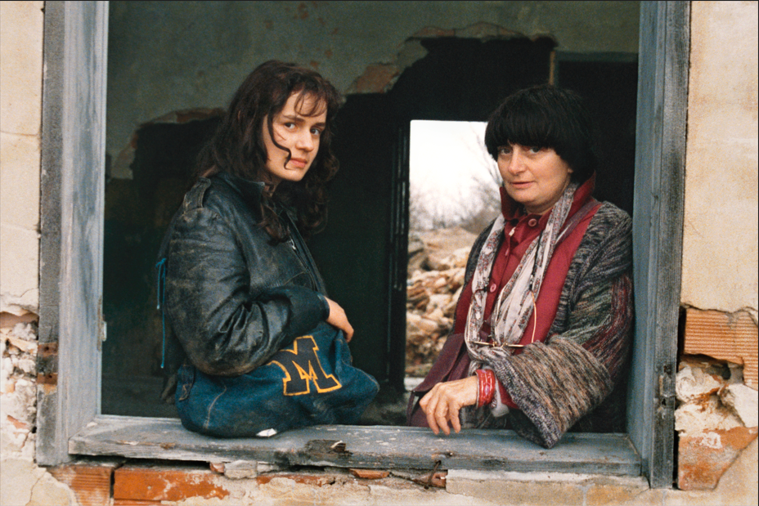
Sandrine Bonnaire and Agnès Varda on set of Vagabond © Ciné-Tamaris

DIRECTOR’S NOTES

On a small rise not far from Montpellier, two cypress trees have intrigued me for a very long time. I imagined a film: Mona would find shelter in a greenhouse near this burial mound and would die in a ditch. The two cypresses would stand watch over her. A screenplay took shape from these precise yet irrational images.
I also understood that the film could not be made up of a series of episodes punctuated by Mona’s movements. Mona’s walking itself is the subject and the guiding line of the film. I imagined thirteen tracking shots, all moving from right to left, each lasting roughly a minute. Between them, Mona encounters all those who will later speak about her, judging her without indulgence and with the ordinary hostility reserved for those who are different. Only during these shots would we hear the strange and powerful music by Joanna Bruzdowicz.
The working title was À saisir (Up for Grabs). We would grasp only fragments of information about her - hence the idea of letting witnesses to her wandering speak. From this structure, which in no way diminished the adventure of shooting the film, it was necessary to convey emotion while preserving Mona’s energy and that of the film itself. For Mona, I was fortunate to have Sandrine Bonnaire, whose talent is dazzling.
As for the themes of the screenplay, they generated their own ideas and dialogue. These themes are: walking, sleeping, eating, smoking, for Mona, but also: the smell of dirt, limited sympathy, marginal figures, immigrant labour, diseases of trees, and the cold that kills.

THE SUBJECT AND IMPACT OF THE FILM
Wandering and filth are subjects that fascinate me. While preparing the film, I observed that vagabonds were becoming increasingly young. In the 1980s, very young women began appearing on roads and under archways - not lost, but determined to live their freedom in a wild and solitary way.
I met several of them. During my location scouting, I picked up a young hitchhiker who spoke to me about her daily struggle to survive. I lost touch with her, then found her again in Nîmes, and I even paid her for her stories and information, which greatly enriched the character of Mona. She knew that it was the smell of vagabonds, more than their poverty, that kept them on the margins of society — where cleanliness is a value. But she did not care.
In 1984, “tramps” were a recognised category, but “road travellers” were only referred to as SDF (Sans Domicile Fixe, no fixed abode) by the police. It was only later that they became a social issue people talked about. At that time, the Salvation Army existed discreetly, convents offered soup to those who knocked at their doors, but Abbé Pierre had not yet re-emerged, Coluche had not yet created Les Restos du Cœur, and the magazines were concerned with other matters.
This is no doubt why, when the film was released in early December 1985, it surprised and attracted so many viewers (1.1 million admissions in France). The Golden Lion at the Venice Film Festival contributed to this, but above all it was the subject — resonating with the bitter cold of that winter — and the extraordinary presence of Sandrine Bonnaire as Mona, an unsympathetic character, that captivated audiences. As did my way of telling the story, without softness. I wanted a harsh film, without indulgence or prettiness.

ABOUT Sandrine Bonnaire
In Vagabond, I asked real people to play themselves in their own environments, and I asked Sandrine not to act, but simply to be herself-as-Mona. Sandrine brought to the character her exceptional presence - a way of inhabiting every step, every gesture. I never spoke to her about Mona’s inner life or her past, but I insisted strongly that she learn how to light a fire, open a tin of sardines with a knife, and walk like those who walk often and for long periods in poor shoes.
The image that remains is that of Mona in a vineyard landscape dominated by two cypress trees and Mona will always have the face of Sandrine Bonnaire.

ABOUT THE CHARACTER OF MONA
Vagabond is built entirely on an uncertainty that becomes certain. Those who have seen Mona pass by speak of her. Each person contributes a piece to the puzzle-portrait of Mona. Each knows only a little and expresses only a single point of view. I, the screenwriter, am not Madame Know-It-All. I have a person-to-person relationship with Mona. She escapes me; I do not grasp her. It is amusing that the word saisir means both to seize and to understand. I chose not to catch the wild bird that is Mona, nor to understand her.
Mona is a character felt and played with intensity by Sandrine Bonnaire, but she is documented through people I had encountered: travellers picked up hitchhiking, including one brought back home. Mona, who ultimately dies of cold, is described by those who saw her pass: a shepherd, a garage mechanic, a road worker, a plasterer, a farmer, a Tunisian labourer… They did not invent their lines, since their testimonies were written by me, but I only wrote them after behaving as though I were preparing a documentary about them and about what they themselves might have thought or said, having observed how they behaved.
Translated from French
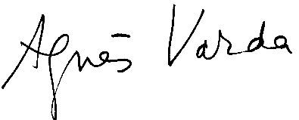

PRESS

"Vagabond is a film which combines everything that Varda does best: a story ripped from the headlines which she refuses to fully fictionalise; a strong female lead who battles against a patriarchal system and against people who can’t comprehend her anxieties; a love of those liminal spaces between cities, roads, buildings – locations which appear as blank spaces on maps; a belief in building stories through small nuance rather than sweeping gestures. On that last point, you must watch this film (or, indeed, rewatch it) for a moment where Mona scoops the contents of a can of fish into her mouth and wipes the oily remnants across her face – a poetic vision of unselfconscious contentment which defines this beautiful character."
David Jenkins, Little White Lies

"Miss Varda forces us to respond to externals, and turns a great risk into a triumph by making Mona difficult to like or understand."
Miss Varda's work is primarily about us as observers, uneasy with our helplessness and our detachment from a character whose outer life has been so relentlessly detailed yet whose thoughts remains buried.
Agnes Varda has created a world too painfully real to ignore."

Caryn James, The New York Times

"An exceptionally beautiful film."
★★★★★
David Jenkins, Little White Lies

"Agnès Varda’s best film."
★★★★★
David Jenkins, Little White Lies

"Often considered to be Agnès Varda’s masterpiece."
★★★★★
David Jenkins, Little White Lies

"Cool, enigmatic and as gripping as any thriller."
★★★★★
Peter Bradshaw, The Guardian

"An unmissable film from this great director."
★★★★★
Peter Bradshaw, The Guardian

"An unmissable film from this great director."
★★★★★
Peter Bradshaw, The Guardian

"Ms. Varda reaches for our humanity with a force that very few movies can muster. Memorable."
Julie Salamon, Wall Street Journal

"What a film this is. Like so many of the greatest films, it tells us a very specific story, strong and unadorned, about a very particular person."
★★★★
Roger Ebert, Chicago Sun-Times

ALICE ROCHWACHER ON VAGABOND

"Agnès Varda is one of the filmmakers I’ve always admired for her great ability to stick to her own voice. I find that irony is something that needs to be cultivated, and the few filmmakers who manage to do that are, for me, great masters. Even when she’s telling stories that are far from her own life, all of her films become like beads in a necklace that shines very brightly and decorates her. And the thing that I find surprising is that when she does tell stories that are so connected to her own gaze and her own life, they still succeed in being universal."
Alice Rochwacher

AGNÈS VARDA – FILMOGRAPHY

FEATURE FILMS
1954 – La Pointe Courte
1962 – Cléo from 5 to 7
1965 – Happiness
1966 – The Creatures
1967 – Far From Vietnam
1969 – Lions Love (... and Lies)
1970 – Nausicaa
1975 – Daguerréotypes
1981 – Mural, Murals
1985 – Vagabond
1987 – Jane B. by Agnès V.
1988 – Kung-Fu Master!
1991 – Jacquot
1995 – One Hundred and One Nights
2000 – The Gleaners and I
2008 – The Beaches of Agnès
2017 – Faces Places
2019 – Varda by Agnès

SHORT FILMS
1958 – Ô saisons, ô châteaux
1958 – Along the Coast
1958 – L’Opéra-Mouffe
1963 – Salut les Cubains
1966 – Elsa la rose
1967 – Uncle Yanco
1968 – Black Panthers
1975 – Women Reply
1976 – The Pleasure of Love in Iran
1982 – Ulysse
1984 – The So-Called Caryatids
2002 – The Gleaners and I: Two Years Later
2004 – Ydessa, the Bears etc.
2006 – Some Widows of Noirmoutier

CAST

Mona Bergeron, a vagabond Sandrine Bonnaire
Madame Landier, a plane tree specialist Macha Méril
Jean-Pierre, an agronomist Stéphane Freiss
Éliane, Jean-Pierre’s wife Laurence Cortadellas
Aunt Lydie, Jean-Pierre’s aunt Marthe Jarnias
Yolande, Lydie’s maid Yolande Moreau
Paulo, Yolande’s boyfriend Joël Fosse
David, the wandering Jew Patrick Lepczynski
Assoun, a vine pruner Yahiaoui Assouna
Mac, a homeless youth at the train station Christian Chessa

CREW

Written by Agnès Varda
Directed by Agnès Varda
Cinematography Patrick Blossier
Sound by Jean-Paul Mugel
Edited by Agnès Varda and Patricia Mazuy
Costume design Rosalie Varda
Produced by Ciné-Tamaris, Films A2
With the participation of The French Ministry of Culture
International Sales / French Distribution mk2 Films

© 1985 Ciné-Tamaris / Films A2

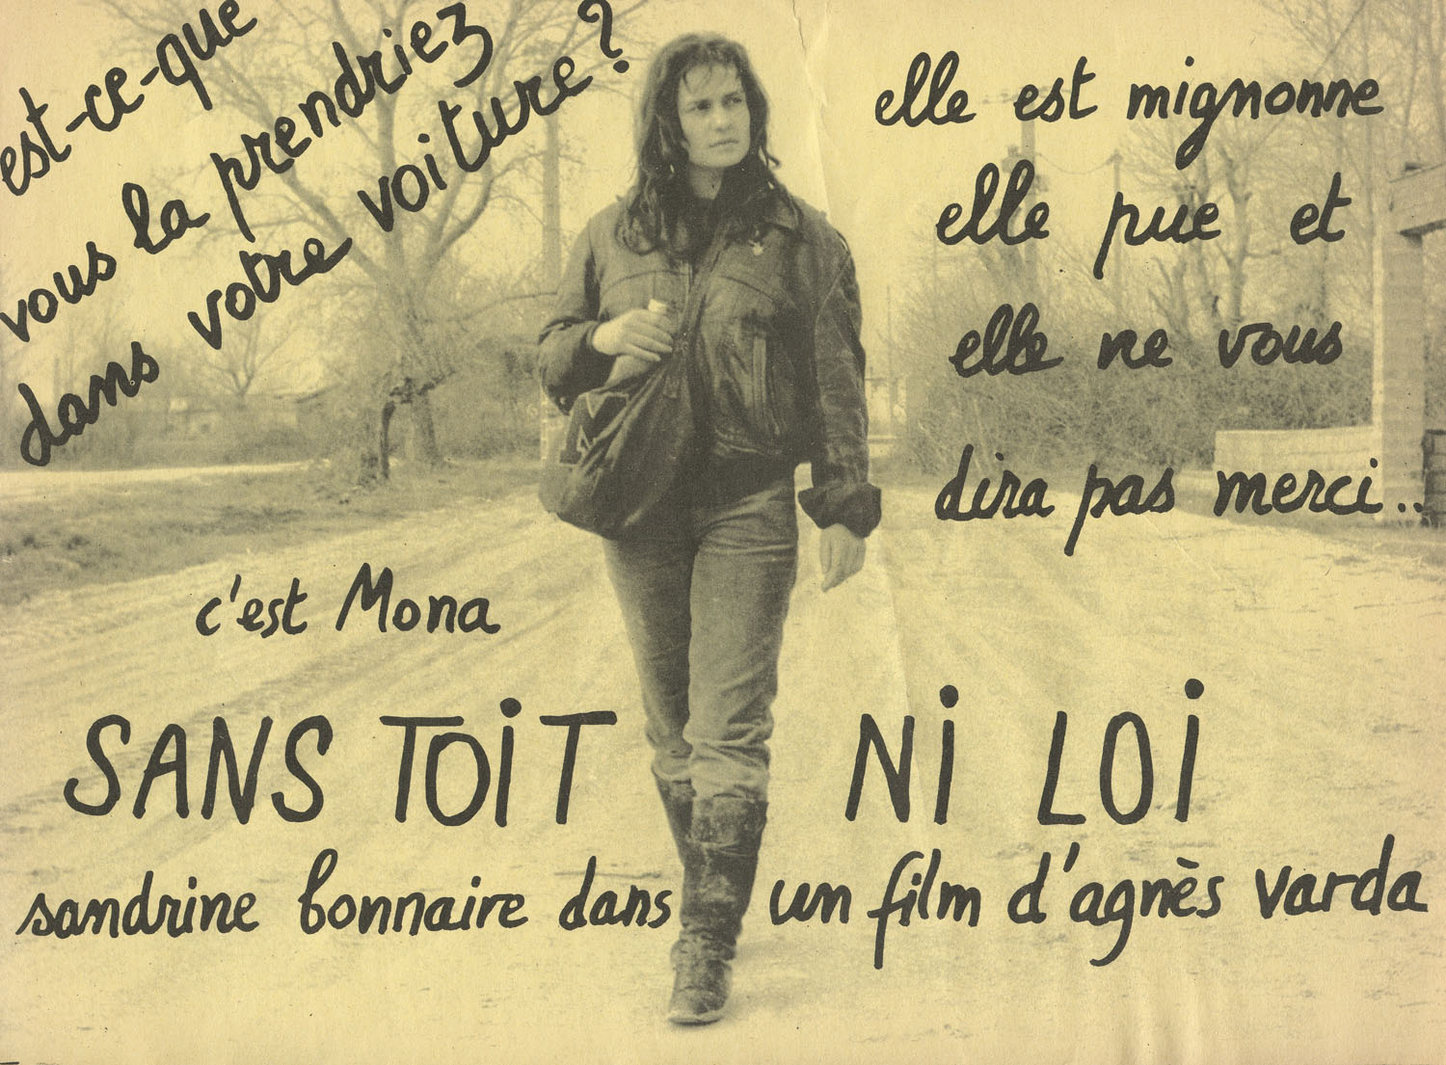
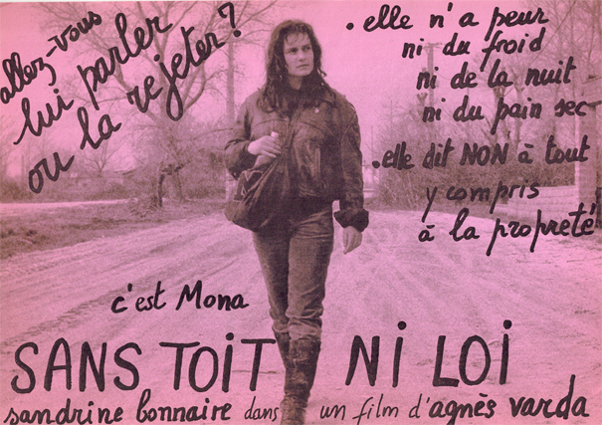
Promotional flyers printed for the release of the film in 1985 © Ciné-Tamaris

